CHAPTER 7
Human Health and Disease
• Human Health and Disease

Ch 7 | HUMAN HEALTH AND DISEASE - Chapter Opener

The term health is very frequently used by everybody.
7.0 | How the idea of health was arrived at

Health, for a long time, was considered as a state of body and mind where there was a balance of certain 'humors'. This is what early Greeks like Hippocrates, as well as the Indian Ayurveda system of medicine, asserted.
Early ideas about health were not experimental. It was thought that persons with 'blackbile' belonged to a hot personality and would have fevers; this idea was arrived at by pure reflective thought, not by measurement.
• The discovery of blood circulation by William Harvey using the experimental method, and
• the demonstration of normal body temperature in persons with blackbile using a thermometer, together disproved the 'good humor' hypothesis of health.
Later biology stated that the mind influences, through the neural system and the endocrine system, our immune system, and that our immune system maintains our health. Hence, mind and mental state can affect our health.
Health is affected by three broad things:
• (i) Genetic disorders - deficiencies with which a child is born, and deficiencies/defects which the child inherits from parents from birth;
• (ii) Infections;
• (iii) Life style - including the food and water we take, the rest and exercise we give to our bodies, and habits that we have or lack, etc.
• Health does not simply mean 'absence of disease' or 'physical fitness'. It could be defined as a state of complete physical, mental and social well-being. The chapter summary states the same definition with one word added: a state of complete physical, mental, social and psychological well-being.
When people are healthy, they are more efficient at work. This increases productivity and brings economic prosperity. Health also increases longevity of people and reduces infant and maternal mortality.
Balanced diet, personal hygiene and regular exercise are very important to maintain good health. Yoga has been practised since time immemorial to achieve physical and mental health.
Also necessary for achieving good health:
• awareness about diseases and their effect on different bodily functions;
• vaccination (immunisation) against infectious diseases;
• proper disposal of wastes;
• control of vectors;
• maintenance of hygiene in food and water resources.
• When the functioning of one or more organs or systems of the body is adversely affected, characterised by appearance of various signs and symptoms, we say that we are not healthy, i.e., we have a disease.
Diseases can be broadly grouped into infectious and non-infectious. Diseases which are easily transmitted from one person to another are called infectious diseases.
Group | What it means | Additional notes
Infectious diseases | Easily transmitted from one person to another. | Very common - every one of us suffers from these at sometime or other. Some, like AIDS, are fatal.
Non-infectious diseases | Not transmitted from person to person. | Cancer is the major cause of death among these. Drug and alcohol abuse also affect our health adversely.

7.1 | COMMON DISEASES IN HUMANS

A wide range of organisms belonging to bacteria, viruses, fungi, protozoans, helminths, etc., could cause diseases in man.
Diseases like typhoid, cholera, pneumonia, fungal infections of skin, malaria and many others are a major cause of distress to human beings.
• Such disease-causing organisms are called pathogens. Most parasites are therefore pathogens, as they cause harm to the host by living in (or on) them.
The pathogens can enter our body by various means, multiply and interfere with normal vital activities, resulting in morphological and functional damage.
Pathogens have to adapt to life within the environment of the host. For example, the pathogens that enter the gut must know a way of surviving in the stomach at low pH and resisting the various digestive enzymes.
7.1a | Typhoid

Salmonella typhi is a pathogenic bacterium which causes typhoid fever in human beings. These pathogens generally enter the small intestine through food and water contaminated with them, and migrate to other organs through blood.
• Symptoms: sustained high fever (39 degrees C to 40 degrees C), weakness, stomach pain, constipation, headache and loss of appetite.
• Intestinal perforation and death may occur in severe cases.
• Diagnosis: typhoid fever could be confirmed by the Widal test.
7.1b | Widal test

The Widal test is the test that confirms typhoid fever.
[NOTE] A classic case in medicine is that of Mary Mallon, nicknamed Typhoid Mary. She was a cook by profession and was a typhoid carrier who continued to spread typhoid for several years through the food she prepared.

7.1c | Pneumonia

Bacteria like Streptococcus pneumoniae and Haemophilus influenzae are responsible for the disease pneumonia in humans, which infects the alveoli (air filled sacs) of the lungs. As a result of the infection, the alveoli get filled with fluid, leading to severe problems in respiration.
• Symptoms: fever, chills, cough and headache. In severe cases, the lips and finger nails may turn gray to bluish in colour.
• Transmission: a healthy person acquires the infection by inhaling the droplets/aerosols released by an infected person, or even by sharing glasses and utensils with an infected person.
Dysentery, plague, diphtheria, etc., are some of the other bacterial diseases in man.
7.1d | Common cold

Rhino viruses represent one such group of viruses which cause one of the most infectious human ailments - the common cold. They infect the nose and respiratory passage but not the lungs.
• Symptoms: nasal congestion and discharge, sore throat, hoarseness, cough, headache, tiredness, etc., which usually last for 3-7 days.
• Transmission: droplets resulting from cough or sneezes of an infected person are either inhaled directly or transmitted through contaminated objects such as pens, books, cups, doorknobs, computer keyboard or mouse, etc., and cause infection in a healthy person.
7.1e | Malaria

Plasmodium, a tiny protozoan, is responsible for this disease. Different species of Plasmodium (P. vivax, P. malaria and P. falciparum) are responsible for different types of malaria. Of these, malignant malaria caused by Plasmodium falciparum is the most serious one and can even be fatal.
Life cycle of the malarial parasite (two hosts, one cycle):
1 | (cycle - last step feeds back to step 1)
2 | Plasmodium enters the human body as sporozoites (infectious form) through the bite of an infected female Anopheles mosquito - when the mosquito bites another human, sporozoites are injected with the bite.
3 | The parasite (sporozoites) reach the liver through blood: the parasites initially multiply within the liver cells, the parasite reproduces asexually in liver cells, bursting the cell and releasing into the blood.
4 | They then attack the red blood cells (RBCs), resulting in their rupture. Parasites reproduce asexually in red blood cells, bursting the red blood cells and causing cycles of fever and other symptoms; released parasites infect new red blood cells.
5 | The rupture of RBCs releases a toxic substance, haemozoin, which is responsible for the chill and high fever recurring every three to four days.
6 | Sexual stages (gametocytes) develop in the red blood cells - the male and female forms shown on the plate.
7 | When a female Anopheles mosquito bites an infected person, these parasites enter the mosquito's body and undergo further development: the female mosquito takes up gametocytes with the blood meal.
8 | Fertilization and development take place in the mosquito's gut.
9 | The parasites multiply within them to form sporozoites that are stored in their salivary glands: the mature infective stages (sporozoites) escape from the gut and migrate to the mosquito salivary glands. When these mosquitoes bite a human, the sporozoites are introduced into his/her body, thereby initiating the events mentioned above.

• The malarial parasite requires two hosts - human and mosquitoes - to complete its life cycle, and the female Anopheles mosquito is the vector (transmitting agent) too.
Reading Figure 7.1: the plate is drawn as two linked loops - the Human Host on one side and the Mosquito Host on the other. Labelled on it are the Sporozoites leaving the mosquito's Salivary glands, and the Gametocytes in the human blood, which are of two kinds, Male and Female.
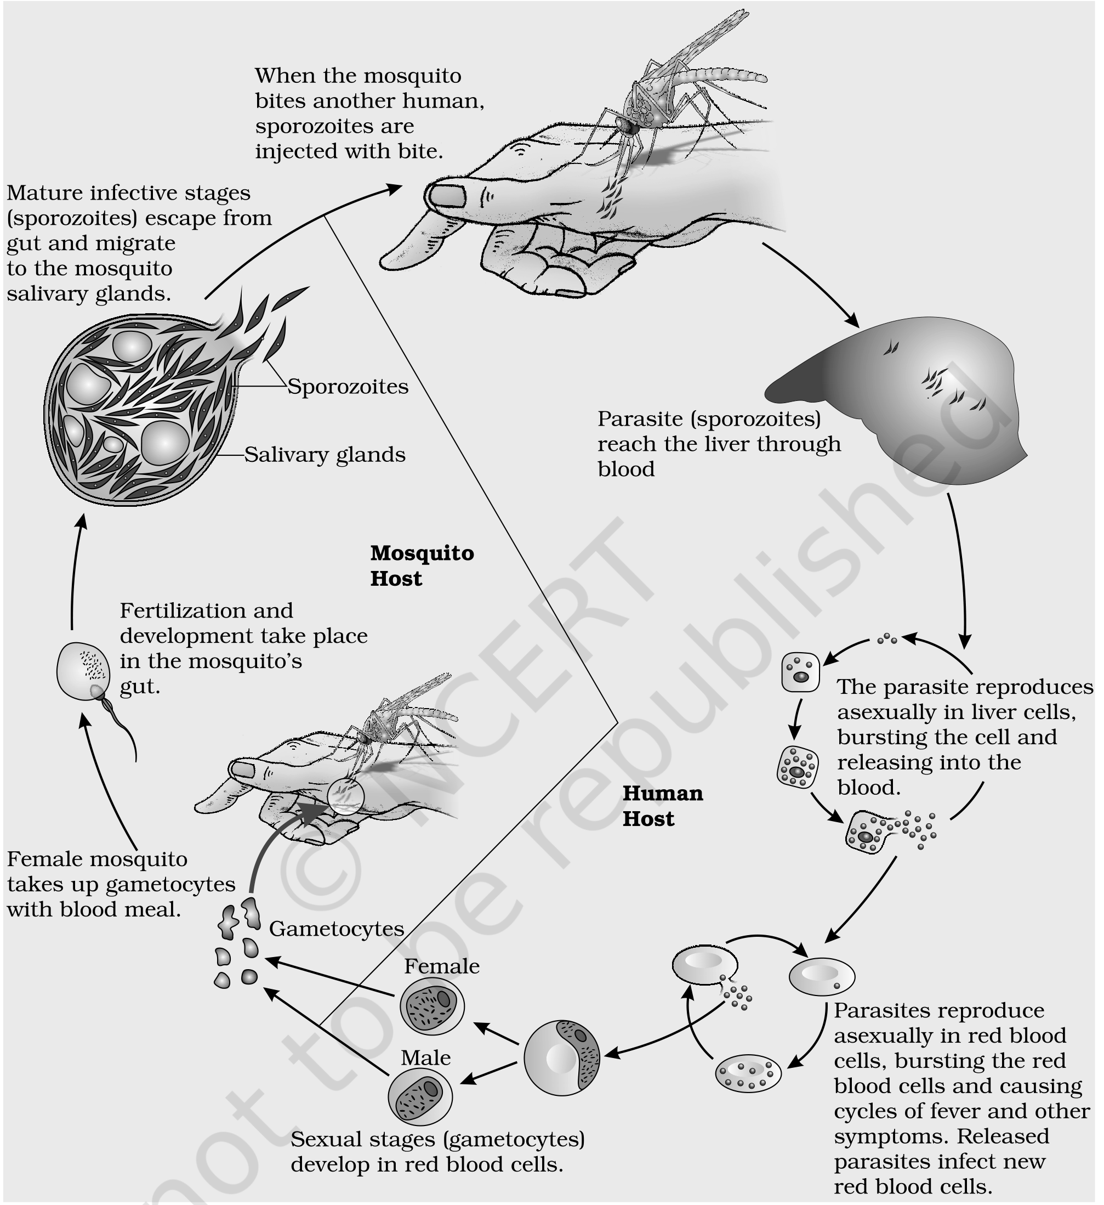
Fig. 7.1 - Stages in the life cycle of Plasmodium.
7.1f | Amoebiasis (amoebic dysentery)

Entamoeba histolytica is a protozoan parasite in the large intestine of human which causes amoebiasis (amoebic dysentery).
• Symptoms: constipation, abdominal pain and cramps, stools with excess mucous and blood clots.
• Transmission: houseflies act as mechanical carriers and serve to transmit the parasite from faeces of infected person to food and food products, thereby contaminating them. Drinking water and food contaminated by the faecal matter are the main source of infection.
7.1g | Helminth diseases - Ascariasis and Filariasis

Ascaris, the common round worm, and Wuchereria, the filarial worm, are some of the helminths which are known to be pathogenic to man. Ascaris, an intestinal parasite, causes ascariasis.
• Symptoms of ascariasis: internal bleeding, muscular pain, fever, anemia and blockage of the intestinal passage.
• Transmission: the eggs of the parasite are excreted along with the faeces of infected persons, which contaminate soil, water, plants, etc. A healthy person acquires this infection through contaminated water, vegetables, fruits, etc.
Wuchereria (W. bancrofti and W. malayi), the filarial worms, cause a slowly developing chronic inflammation of the organs in which they live for many years, usually the lymphatic vessels of the lower limbs, and the disease is called elephantiasis or filariasis. The genital organs are also often affected, resulting in gross deformities. The pathogens are transmitted to a healthy person through the bite by the female mosquito vectors.
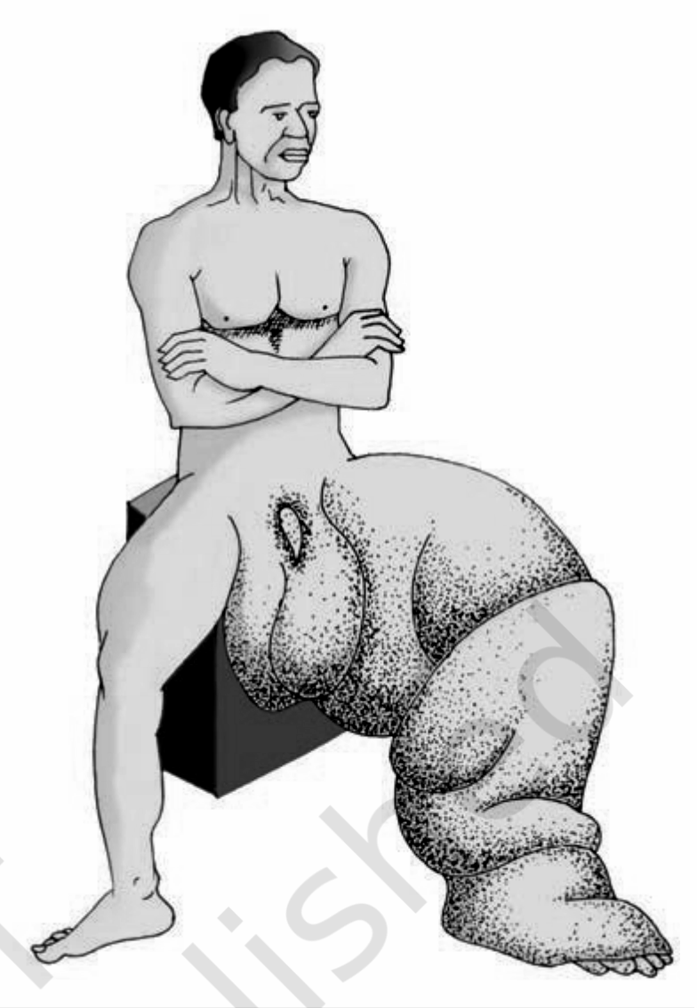
Fig. 7.2 - Diagram showing inflammation in one of the lower limbs due to elephantiasis. The plate is an unlabelled illustration; the swelling shown is the chronic inflammation of the lymphatic vessels of the lower limb described above.
7.1h | Ringworms

Many fungi belonging to the genera Microsporum, Trichophyton and Epidermophyton are responsible for ringworms, which is one of the most common infectious diseases in man.
• Symptoms: appearance of dry, scaly lesions on various parts of the body such as skin, nails and scalp. These lesions are accompanied by intense itching.
• Heat and moisture help these fungi to grow, which makes them thrive in skin folds such as those in the groin or between the toes.
• Transmission: ringworms are generally acquired from soil, or by using towels, clothes or even the comb of infected individuals.
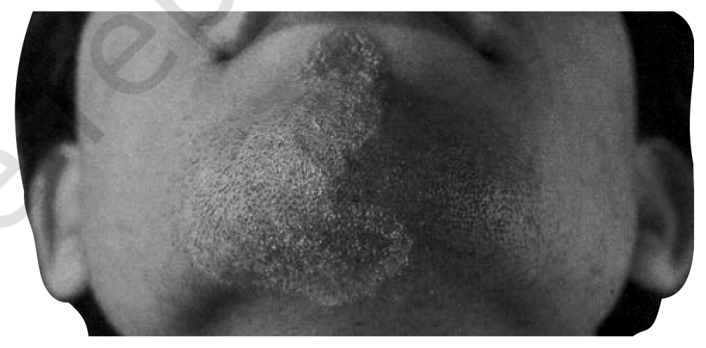
Fig. 7.3 - Diagram showing ringworm affected area of the skin. The plate is an unlabelled photograph of a lesion on the chin and jaw - one of the dry, scaly, intensely itching lesions described above.
7.1i | Prevention and control of infectious diseases

Level of hygiene | What NCERT includes in it
Personal hygiene | Keeping the body clean; consumption of clean drinking water, food, vegetables, fruits, etc.
Public hygiene | Proper disposal of waste and excreta; periodic cleaning and disinfection of water reservoirs, pools, cesspools and tanks; and observing standard practices of hygiene in public catering.

These measures are particularly essential where the infectious agents are transmitted through food and water - such as typhoid, amoebiasis and ascariasis. Because they travel in contaminated food and water, these three are exactly the diseases that a question calls water-borne; the chapter calls the other two routes air-borne and vector-borne.
• In cases of air-borne diseases such as pneumonia and common cold, in addition to the above measures, close contact with the infected persons or their belongings should be avoided.
• For diseases such as malaria and filariasis that are transmitted through insect vectors, the most important measure is to control or eliminate the vectors and their breeding places. This can be achieved by:
- avoiding stagnation of water in and around residential areas;
- regular cleaning of household coolers;
- use of mosquito nets;
- introducing fishes like Gambusia in ponds that feed on mosquito larvae;
- spraying of insecticides in ditches, drainage areas and swamps, etc.;
- providing doors and windows with wire mesh to prevent the entry of mosquitoes.
Such precautions have become more important especially in the light of recent widespread incidences of the vector-borne (Aedes mosquitoes) diseases like dengue and chikungunya in many parts of India.
• The use of vaccines and immunisation programmes has enabled us to completely eradicate a deadly disease like smallpox.
• A large number of other infectious diseases like polio, diphtheria, pneumonia and tetanus have been controlled to a large extent by the use of vaccines.
• Biotechnology (about which you will read more in Chapter 10) is at the verge of making available newer and safer vaccines.
• Discovery of antibiotics and various other drugs has also enabled us to effectively treat infectious diseases.
7.2 | IMMUNITY

Everyday we are exposed to a large number of infectious agents. However, only a few of these exposures result in disease. Why? Because the body is able to defend itself from most of these foreign agents.
• This overall ability of the host to fight the disease-causing organisms, conferred by the immune system, is called immunity. Immunity is of two types: (i) Innate immunity and (ii) Acquired immunity.
7.2.1 | Innate Immunity

Innate immunity is non-specific type of defence, that is present at the time of birth.
This is accomplished by providing different types of barriers to the entry of the foreign agents into our body. Innate immunity consists of four types of barriers.
7.2.1 (i) | Physical barriers

Physical barriers: Skin on our body is the main barrier which prevents entry of the micro-organisms. Mucus coating of the epithelium lining the respiratory, gastrointestinal and urogenital tracts also helps in trapping microbes entering our body.
7.2.1 (ii) | Physiological barriers

Physiological barriers: Acid in the stomach, saliva in the mouth, tears from eyes - all prevent microbial growth.
7.2.1 (iii) | Cellular barriers

Cellular barriers: Certain types of leukocytes (WBC) of our body like polymorpho-nuclear leukocytes (PMNL-neutrophils) and monocytes and natural killer (type of lymphocytes) in the blood, as well as macrophages in tissues, can phagocytose and destroy microbes.
7.2.1 (iv) | Cytokine barriers

Cytokine barriers: Virus-infected cells secrete proteins called interferons which protect non-infected cells from further viral infection.
[MEMORY AID - not in NCERT] The four innate barriers, in the order the chapter presents them, read P-P-C-C: Physical, Physiological, Cellular, Cytokine - skin first, then secretions, then cells, then the proteins cells secrete.

7.2.2 | Acquired Immunity

Acquired immunity, on the other hand, is pathogen specific. It is characterised by memory.
When our body encounters a pathogen for the first time it produces a response called primary response, which is of low intensity. Subsequent encounter with the same pathogen elicits a highly intensified secondary or anamnestic response. This is because our body appears to have memory of the first encounter.
The primary and secondary immune responses are carried out with the help of two special types of lymphocytes present in our blood, i.e., B-lymphocytes and T-lymphocytes. The B-lymphocytes produce an army of proteins in response to pathogens into our blood to fight with them; these proteins are called antibodies. The T-cells themselves do not secrete antibodies but help B cells to produce them.
• Each antibody molecule has four peptide chains: two small called light chains and two longer called heavy chains. Hence, an antibody is represented as H₂L₂.
Reading Figure 7.4: the plate labels the two Antigen binding site regions at the top of the Y, each Light chain on the outside and each Heavy chain in the middle. Every chain is marked at its ends: N at the amino terminus and C at each carboxyl terminus. The S-S marks are disulfide bonds - the two heavy chains are held to each other, and each light chain to its heavy chain, by disulfide bonds.
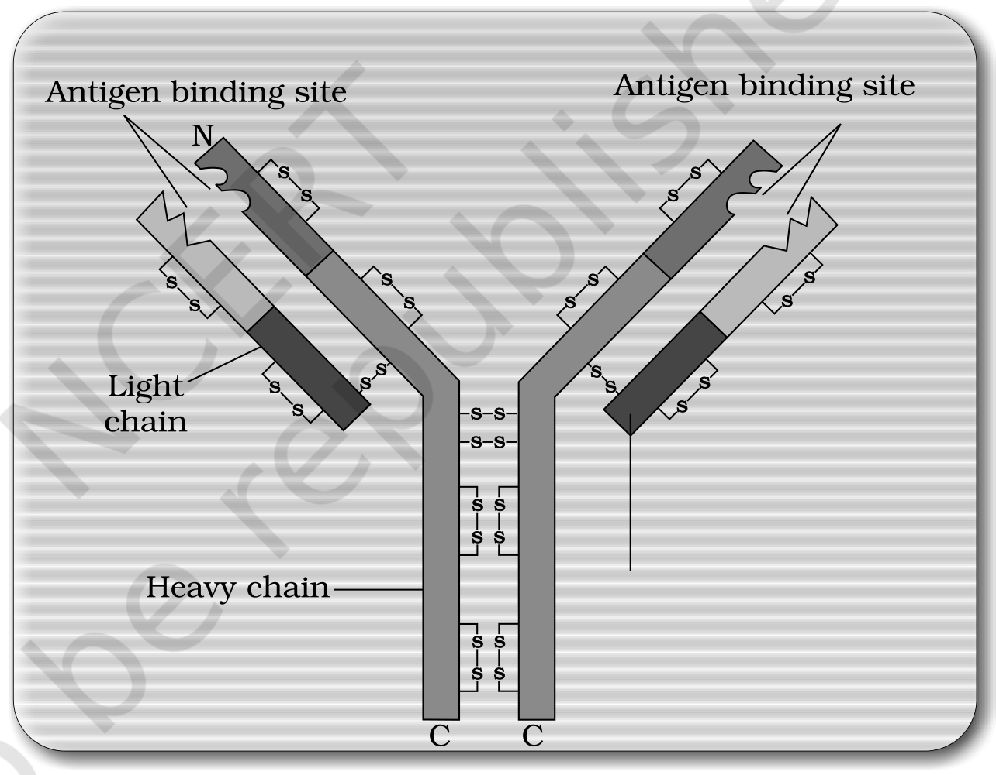
Fig. 7.4 - Structure of an antibody molecule.
Different types of antibodies are produced in our body. IgA, IgM, IgE, IgG are some of them.
Type of acquired immune response | Carried out by | Why it is named so
Humoral immune response (antibody mediated) | Antibodies produced by B-lymphocytes | Because these antibodies are found in the blood. This is one of the two types of our acquired immune response.
Cell-mediated immune response or cell-mediated immunity (CMI) | T-lymphocytes mediate CMI | The second type - mediated by cells, not by antibodies in the blood.

7.2.2a | Transplantation and graft rejection

Very often, when some human organs like heart, eye, liver, kidney fail to function satisfactorily, transplantation is the only remedy to enable the patient to live a normal life.
• Grafts from just any source - an animal, another primate, or any human beings - cannot be made, since the grafts would be rejected sooner or later.
• Tissue matching and blood group matching are essential before undertaking any graft/transplant, and even after this the patient has to take immuno-suppresants all his/her life.
• The body is able to differentiate 'self' and 'nonself', and the cell-mediated immune response is responsible for the graft rejection.
7.2.3 | Active and Passive Immunity

When a host is exposed to antigens, which may be in the form of living or dead microbes or other proteins, antibodies are produced in the host body.
 | Active immunity | Passive immunity
What it is | The immunity produced when the host itself makes antibodies after exposure to antigens. | When ready-made antibodies are directly given to protect the body against foreign agents.
Speed | Slow - takes time to give its full effective response. | Immediate protection, because the antibodies are already formed.
How it is induced | Injecting the microbes deliberately during immunisation, or infectious organisms gaining access into body during natural infection. | Antibodies made elsewhere are transferred in.

• The yellowish fluid colostrum secreted by the mother during the initial days of lactation has abundant antibodies (IgA) to protect the infant.
• The foetus also receives some antibodies from their mother, through the placenta during pregnancy. These are some examples of passive immunity.
7.2.4 | Vaccination and Immunisation

The principle of immunisation or vaccination is based on the property of 'memory' of the immune system.
1 | In vaccination, a preparation of antigenic proteins of pathogen or inactivated/weakened pathogen (vaccine) is introduced into the body.
2 | The antibodies produced in the body against these antigens would neutralise the pathogenic agents during actual infection.
3 | The vaccines also generate memory - B and T-cells that recognise the pathogen quickly on subsequent exposure and overwhelm the invaders with a massive production of antibodies.

If a person is infected with some deadly microbes to which quick immune response is required, as in tetanus, we need to directly inject the preformed antibodies, or antitoxin (a preparation containing antibodies to the toxin). Even in cases of snakebites, the injection which is given to the patients contains preformed antibodies against the snake venom. This type of immunisation is called passive immunisation.
Recombinant DNA technology has allowed the production of antigenic polypeptides of pathogen in bacteria or yeast. Vaccines produced using this approach allow large scale production and hence greater availability for immunisation, e.g., hepatitis B vaccine produced from yeast.
7.2.5 | Allergies

When you have gone to a new place and suddenly you started sneezing, wheezing for no explained reason, and when you went away your symptoms disappeared - some of us are sensitive to some particles in the environment. The above-mentioned reaction could be because of allergy to pollen, mites, etc., which are different in different places.
• The exaggerated response of the immune system to certain antigens present in the environment is called allergy. The substances to which such an immune response is produced are called allergens. The antibodies produced to these are of IgE type.
• Common examples of allergens: mites in dust, pollens, animal dander, etc.
• Symptoms: sneezing, watery eyes, running nose and difficulty in breathing.
• Cause: allergy is due to the release of chemicals like histamine and serotonin from the mast cells.
• Determining the cause: the patient is exposed to or injected with very small doses of possible allergens, and the reactions studied.
• Treatment: the use of drugs like anti-histamine, adrenalin and steroids quickly reduce the symptoms of allergy.
[NOTE] Modern-day life style has resulted in lowering of immunity and more sensitivity to allergens - more and more children in metro cities of India suffer from allergies and asthma due to sensitivity to the environment. This could be because of the protected environment provided early in life.

7.2.6 | Auto Immunity

Memory-based acquired immunity evolved in higher vertebrates based on the ability to differentiate foreign organisms (e.g., pathogens) from self-cells.
While we still do not understand the basis of this, two corollaries of this ability have to be understood:
• One, higher vertebrates can distinguish foreign molecules as well as foreign organisms. Most of the experimental immunology deals with this aspect.
• Two, sometimes, due to genetic and other unknown reasons, the body attacks self-cells. This results in damage to the body and is called auto-immune disease.
Rheumatoid arthritis, which affects many people in our society, is an auto-immune disease.
7.2.7 | Immune System in the Body

The human immune system consists of lymphoid organs, tissues, cells and soluble molecules like antibodies.
The immune system is unique in the sense that it recognises foreign antigens, responds to these and remembers them. The immune system also plays an important role in allergic reactions, auto-immune diseases and organ transplantation.
7.2.7a | Lymphoid organs

• Lymphoid organs: These are the organs where origin and/or maturation and proliferation of lymphocytes occur.
Class | Which organs | What happens there
Primary lymphoid organs | Bone marrow and thymus | Immature lymphocytes differentiate into antigen-sensitive lymphocytes.
Secondary lymphoid organs | Spleen, lymph nodes, tonsils, Peyer's patches of small intestine and appendix | After maturation the lymphocytes migrate here. They provide the sites for interaction of lymphocytes with the antigen, which then proliferate to become effector cells.

• Bone marrow is the main lymphoid organ where all blood cells including lymphocytes are produced.
• The thymus is a lobed organ located near the heart and beneath the breastbone. It is quite large at the time of birth but keeps reducing in size with age, and by the time puberty is attained it reduces to a very small size.
• Both bone-marrow and thymus provide micro-environments for the development and maturation of T-lymphocytes.
• The spleen is a large bean-shaped organ. It mainly contains lymphocytes and phagocytes. It acts as a filter of the blood by trapping blood-borne micro-organisms. Spleen also has a large reservoir of erythrocytes.
• The lymph nodes are small solid structures located at different points along the lymphatic system. They serve to trap the micro-organisms or other antigens which happen to get into the lymph and tissue fluid. Antigens trapped in the lymph nodes are responsible for the activation of lymphocytes present there and cause the immune response.
Reading Figure 7.5: the plate marks the Lymph nodes at points along the body, the Thymus behind the breastbone, and the Lymphatic vessels that connect them.
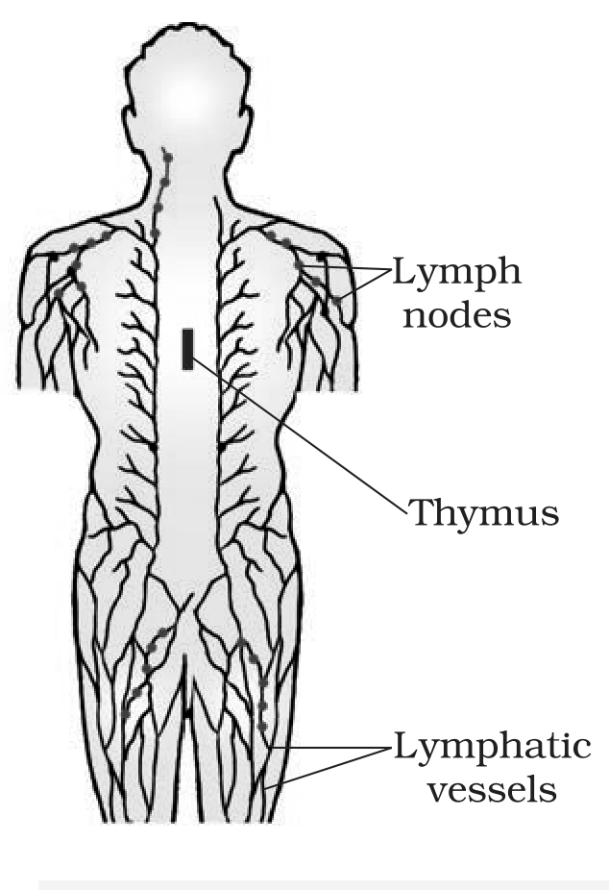
Fig. 7.5 - Diagrammatic representation of Lymph nodes.
• There is lymphoid tissue also located within the lining of the major tracts (respiratory, digestive and urogenital tracts) called mucosa-associated lymphoid tissue (MALT). It constitutes about 50 per cent of the lymphoid tissue in human body.
7.3 | AIDS

• The word AIDS stands for Acquired Immuno Deficiency Syndrome. This means deficiency of immune system, acquired during the lifetime of an individual - indicating that it is not a congenital disease. 'Syndrome' means a group of symptoms.
AIDS was first reported in 1981 and in the last twenty-five years or so, it has spread all over the world, killing more than 25 million persons.
• AIDS is caused by the Human Immuno deficiency Virus (HIV), a member of a group of viruses called retrovirus, which have an envelope enclosing the RNA genome.
Transmission of HIV-infection generally occurs by:
• (a) sexual contact with infected person;
• (b) by transfusion of contaminated blood and blood products;
• (c) by sharing infected needles as in the case of intravenous drug abusers;
• (d) from infected mother to her child through placenta.
People who are at high risk of getting this infection include:
- individuals who have multiple sexual partners;
- drug addicts who take drugs intravenously;
- individuals who require repeated blood transfusions;
- children born to an HIV infected mother.
[NOTE] HIV/AIDS is not spread by mere touch or physical contact; it spreads only through body fluids. It is, hence, imperative, for the physical and psychological well-being, that the HIV/AIDS infected persons are not isolated from family and society.

There is always a time-lag between the infection and appearance of AIDS symptoms. This period may vary from a few months to many years (usually 5-10 years).
What HIV does after it gets into the body:
1 | After getting into the body of the person, the virus enters into macrophages - the virus infects a normal cell and viral RNA is introduced into the cell.
2 | Inside the macrophage, the RNA genome of the virus replicates to form viral DNA with the help of the enzyme reverse transcriptase - that is, viral DNA is produced by reverse transcriptase.
3 | This viral DNA gets incorporated into host cell's DNA - the viral DNA incorporates into the host genome - and directs the infected cells to produce virus particles: new viral RNA is produced by the infected cell and new viruses are produced, which can infect other cells.
4 | The macrophages continue to produce virus and in this way act like an HIV factory. On the plate this is set down as a note: the infected cell can survive while viruses are being replicated and released.
5 | Simultaneously, HIV enters into helper T-lymphocytes (T_{H}), replicates and produces progeny viruses.
6 | The progeny viruses released in the blood attack other helper T-lymphocytes. This is repeated, leading to a progressive decrease in the number of helper T-lymphocytes in the body of the infected person.

Reading Figure 7.6: the plate follows one Retrovirus into one Animal cell. The virus is drawn as a Viral RNA core inside a Viral protein coat. It fuses with the cell's Plasma membrane, releases its contents into the Cytoplasm, where reverse transcriptase makes DNA from the viral RNA, and that DNA then travels into the Nucleus to join the host genome.
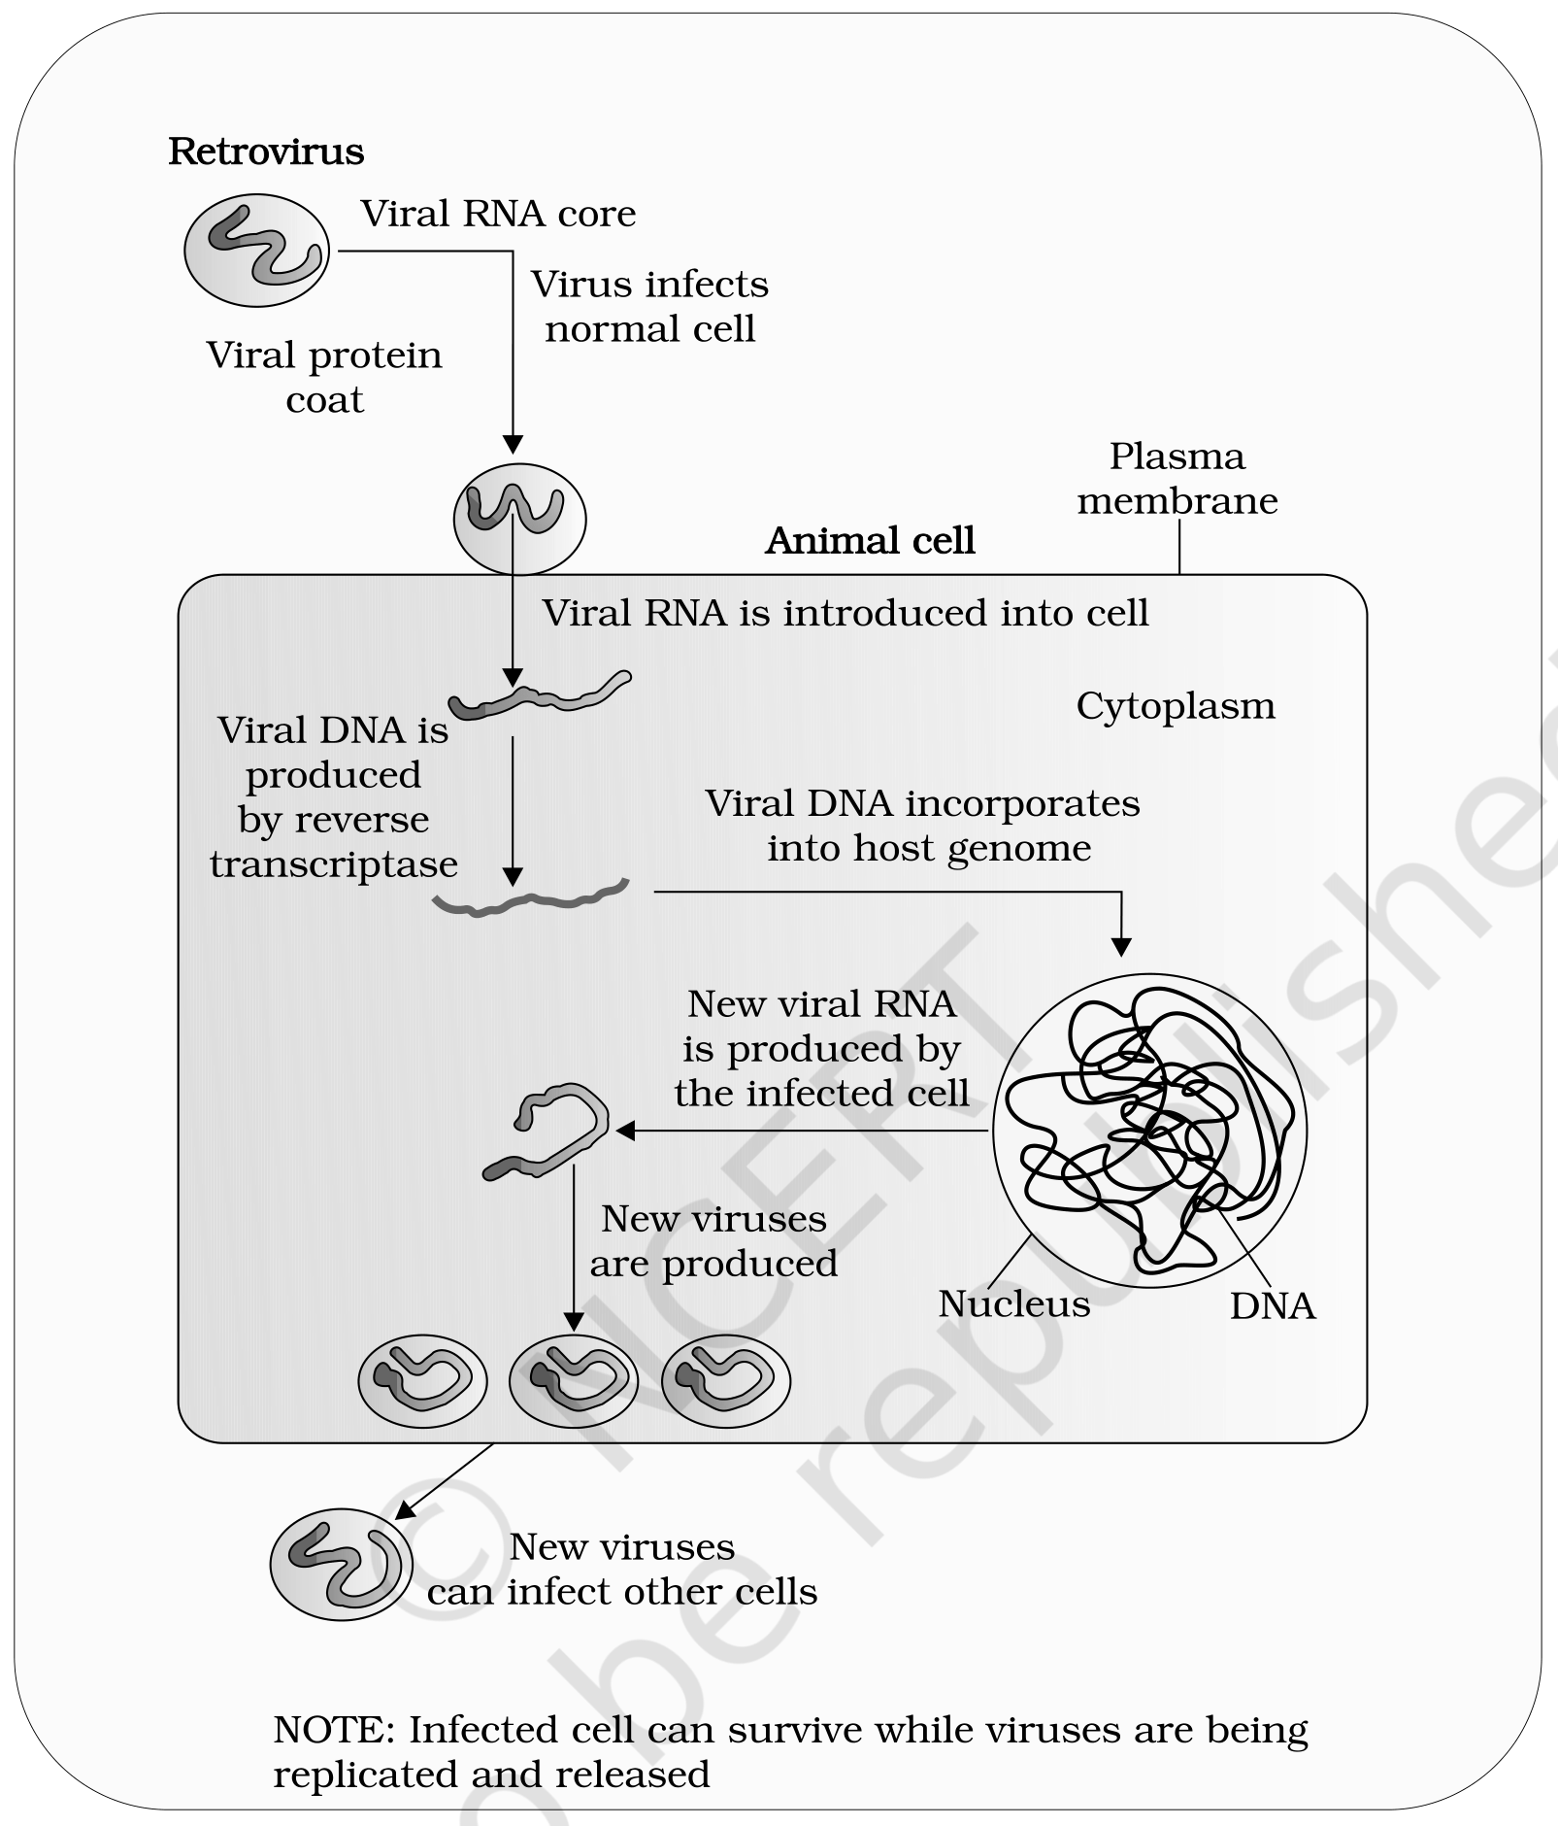
Fig. 7.6 - Replication of retrovirus.
• During this period, the person suffers from bouts of fever, diarrhoea and weight loss.
• Due to the decrease in the number of helper T lymphocytes, the person starts suffering from infections that could have been otherwise overcome - such as those due to bacteria especially Mycobacterium, viruses, fungi and even parasites like Toxoplasma.
• The patient becomes so immuno-deficient that he/she is unable to protect himself/herself against these infections.
• Diagnosis: a widely used diagnostic test for AIDS is enzyme linked immuno-sorbent assay (ELISA).
• Treatment: treatment of AIDS with anti-retroviral drugs is only partially effective. They can only prolong the life of the patient but cannot prevent death, which is inevitable.
7.3a | Prevention of AIDS

As AIDS has no cure, prevention is the best option.
HIV infection, more often, spreads due to conscious behaviour patterns and is not something that happens inadvertently, like pneumonia or typhoid. Infection in blood transfusion patients, new-borns (from mother), etc., may take place due to poor monitoring. The only excuse may be ignorance, and it has been rightly said - 'don't die of ignorance'.
In our country the National AIDS Control Organisation (NACO) and other non-governmental organisations (NGOs) are doing a lot to educate people about AIDS. WHO has started a number of programmes to prevent the spreading of HIV infection.
Some such steps taken up:
• making blood (from blood banks) safe from HIV;
• ensuring the use of only disposable needles and syringes in public and private hospitals and clinics;
• free distribution of condoms;
• controlling drug abuse;
• advocating safe sex;
• promoting regular check-ups for HIV in susceptible populations.
[NOTE] Infection with HIV or having AIDS is something that should not be hidden - since then, the infection may spread to many more people. HIV/AIDS-infected people need help and sympathy instead of being shunned by society. Unless society recognises it as a problem to be dealt with in a collective manner, the chances of wider spread of the disease increase manifold. It is a malady that can only be tackled by the society and medical fraternity acting together, to prevent the spread of the disease.

7.4 | CANCER

Cancer is one of the most dreaded diseases of human beings and is a major cause of death all over the globe.
More than a million Indians suffer from cancer and a large number of them die from it annually. The mechanisms that underlie development of cancer, or oncogenic transformation of cells, its treatment and control have been some of the most intense areas of research in biology and medicine.
In our body, cell growth and differentiation is highly controlled and regulated. In cancer cells there is breakdown of these regulatory mechanisms.
• Normal cells show a property called contact inhibition, by virtue of which contact with other cells inhibits their uncontrolled growth. Cancer cells appear to have lost this property.
• Cancerous cells just continue to divide, giving rise to masses of cells called tumors. Tumors are of two types: benign and malignant.
7.4a | Benign versus malignant tumors

 | Benign tumor | Malignant tumor
Where it stays | Normally remains confined to its original location and does not spread to other parts of the body. | A mass of proliferating cells called neoplastic or tumor cells.
Damage caused | Causes little damage. | These cells grow very rapidly, invading and damaging the surrounding normal tissues. As these cells actively divide and grow they also starve the normal cells by competing for vital nutrients.
Spread | Does not spread. | Cells sloughed from such tumors reach distant sites through blood, and wherever they get lodged in the body, they start a new tumor there. This property, called metastasis, is the most feared property of malignant tumors.

[MEMORY AID - not in NCERT] Benign stays, malignant travels. The one word to attach to malignant tumors is metastasis - new tumors started at distant sites by cells carried there in the blood.

7.4b | Causes of cancer

• Transformation of normal cells into cancerous neoplastic cells may be induced by physical, chemical or biological agents. These agents are called carcinogens.
• Ionising radiations like X-rays and gamma rays, and non-ionizing radiations like UV, cause DNA damage leading to neoplastic transformation.
• The chemical carcinogens present in tobacco smoke have been identified as a major cause of lung cancer.
• Cancer causing viruses called oncogenic viruses have genes called viral oncogenes.
• Several genes called cellular oncogenes (c-onc) or proto oncogenes have been identified in normal cells which, when activated under certain conditions, could lead to oncogenic transformation of the cells.
7.4c | Cancer detection and diagnosis

Early detection of cancers is essential as it allows the disease to be treated successfully in many cases.
• Cancer detection is based on biopsy and histopathological studies of the tissue, and blood and bone marrow tests for increased cell counts in the case of leukemias.
• In biopsy, a piece of the suspected tissue cut into thin sections is stained and examined under microscope (histopathological studies) by a pathologist.
Technique | What it uses | What it is used for
Radiography | Use of X-rays. | Very useful to detect cancers of the internal organs.
CT (computed tomography) | Uses X-rays to generate a three-dimensional image of the internals of an object. | Very useful to detect cancers of the internal organs.
MRI (magnetic resonance imaging) | Uses strong magnetic fields and non-ionising radiations. | Accurately detects pathological and physiological changes in the living tissue.

• Antibodies against cancer-specific antigens are also used for detection of certain cancers.
• Techniques of molecular biology can be applied to detect genes in individuals with inherited susceptibility to certain cancers.
• Identification of such genes, which predispose an individual to certain cancers, may be very helpful in prevention of cancers. Such individuals may be advised to avoid exposure to particular carcinogens to which they are susceptible (e.g., tobacco smoke in case of lung cancer).
7.4d | Treatment of cancer

The common approaches for treatment of cancer are surgery, radiation therapy and immunotherapy.
• In radiotherapy, tumor cells are irradiated lethally, taking proper care of the normal tissues surrounding the tumor mass.
• Several chemotherapeutic drugs are used to kill cancerous cells. Some of these are specific for particular tumors. Majority of drugs have side effects like hair loss, anemia, etc.
• Most cancers are treated by combination of surgery, radiotherapy and chemotherapy.
• Tumor cells have been shown to avoid detection and destruction by immune system. Therefore, the patients are given substances called biological response modifiers such as alpha-interferon, which activates their immune system and helps in destroying the tumor.
7.5 | DRUGS AND ALCOHOL ABUSE

Surveys and statistics show that use of drugs and alcohol has been on the rise especially among the youth. This is really a cause of concern as it could result in many harmful effects. Proper education and guidance would enable youth to safeguard themselves against these dangerous behaviour patterns and follow healthy lifestyles.
• The drugs which are commonly abused are opioids, cannabinoids and coca alkaloids. Majority of these are obtained from flowering plants. Some are obtained from fungi.
7.5a | Opioids

• Opioids are the drugs which bind to specific opioid receptors present in our central nervous system and gastrointestinal tract.
• Heroin, commonly called smack, is chemically diacetylmorphine - a white, odourless, bitter crystalline compound.
• This is obtained by acetylation of morphine, which is extracted from the latex of poppy plant Papaver somniferum.
• Generally taken by snorting and injection, heroin is a depressant and slows down body functions.
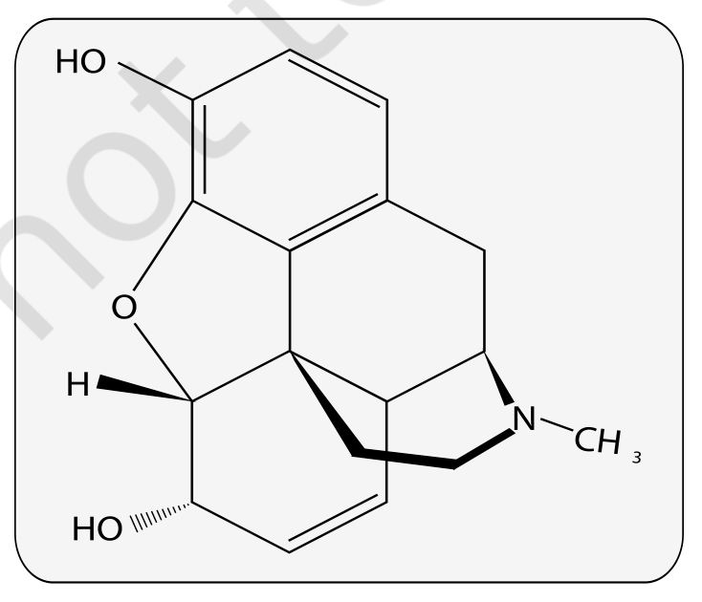
Fig. 7.7 - Chemical structure of Morphine. The plate is a skeletal formula carrying only atom and group symbols (HO, O, H, N and CH₃) and no descriptive labels.
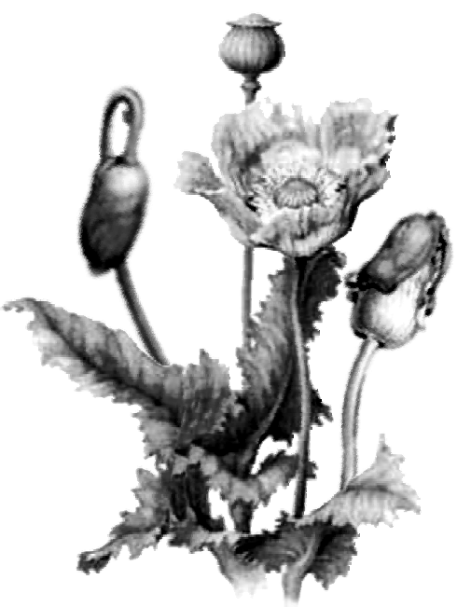
Fig. 7.8 - Opium poppy. An unlabelled illustration of the poppy plant Papaver somniferum, from whose latex morphine is extracted.
7.5b | Cannabinoids

• Cannabinoids are a group of chemicals which interact with cannabinoid receptors present principally in the brain.
• Natural cannabinoids are obtained from the inflorescences of the plant Cannabis sativa.
• The flower tops, leaves and the resin of the cannabis plant are used in various combinations to produce marijuana, hashish, charas and ganja.
• Generally taken by inhalation and oral ingestion, these are known for their effects on cardiovascular system of the body.
• These days cannabinoids are also being abused by some sportspersons.
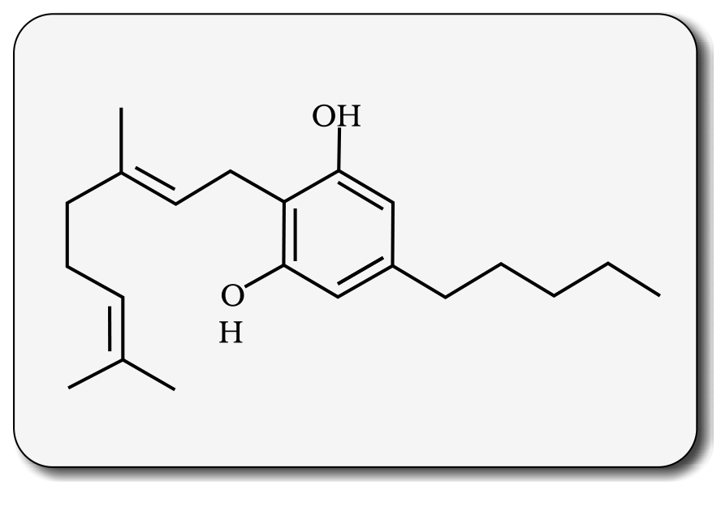
Fig. 7.9 - Skeletal structure of cannabinoid molecule. The plate is a skeletal formula carrying only atom and group symbols (OH, O and H) and no descriptive labels.

Fig. 7.10 - Leaves of Cannabis sativa. An unlabelled framed illustration of the leaf of the plant whose inflorescences yield the natural cannabinoids.
7.5c | Coca alkaloids and other hallucinogenic plants

• Coca alkaloid or cocaine is obtained from coca plant Erythroxylum coca, native to South America. It interferes with the transport of the neuro-transmitter dopamine.
• Cocaine, commonly called coke or crack, is usually snorted. It has a potent stimulating action on central nervous system, producing a sense of euphoria and increased energy. Excessive dosage of cocaine causes hallucinations.
• Other well-known plants with hallucinogenic properties are Atropa belladona and Datura.
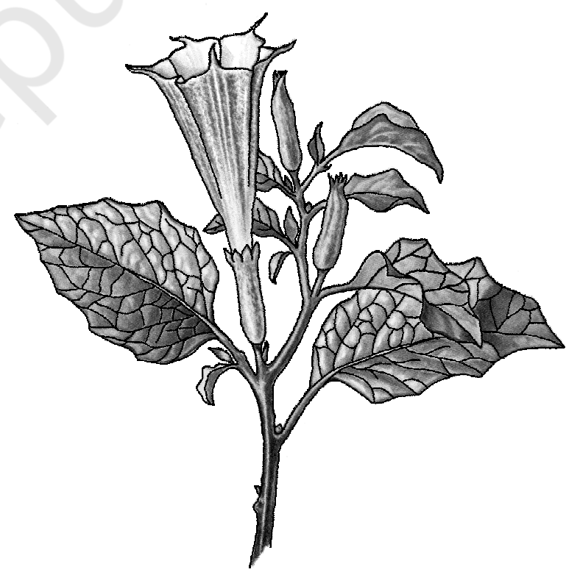
Fig. 7.11 - Flowering branch of Datura. An unlabelled illustration of a flowering branch of Datura, one of the two well-known plants with hallucinogenic properties named above.
7.5d | Medicines that are abused, and what drug abuse means

• Drugs like barbiturates, amphetamines, benzodiazepines, and other similar drugs, that are normally used as medicines to help patients cope with mental illnesses like depression and insomnia, are often abused.
• Morphine is a very effective sedative and painkiller, and is very useful in patients who have undergone surgery.
• Several plants, fruits and seeds having hallucinogenic properties have been used for hundreds of years in folk-medicine, religious ceremonies and rituals all over the globe.
• When these are taken for a purpose other than medicinal use, or in amounts/frequency that impairs one's physical, physiological or psychological functions, it constitutes drug abuse.
7.5e | Tobacco and smoking

Tobacco has been used by human beings for more than 400 years. It is smoked, chewed or used as a snuff. Tobacco contains a large number of chemical substances including nicotine, an alkaloid.
• Nicotine stimulates adrenal gland to release adrenaline and nor-adrenaline into blood circulation, both of which raise blood pressure and increase heart rate.
• Smoking is associated with increased incidence of cancers of lung, urinary bladder and throat, bronchitis, emphysema, coronary heart disease, gastric ulcer, etc.
• Tobacco chewing is associated with increased risk of cancer of the oral cavity.
• Smoking increases carbon monoxide (CO) content in blood and reduces the concentration of haem-bound oxygen. This causes oxygen deficiency in the body.
• Smoking also paves the way to hard drugs.
[NOTE] When one buys packets of cigarettes one cannot miss the statutory warning that is present on the packing, which warns against smoking and says how it is injurious to health. Yet, smoking is very prevalent in society, both among young and old. Knowing the dangers of smoking and chewing tobacco, and its addictive nature, the youth and old need to avoid these habits. Any addict requires counselling and medical help to get rid of the habit.

7.5.1 | Adolescence and Drug/Alcohol Abuse

• Adolescence means both 'a period' and 'a process' during which a child becomes mature in terms of his/her attitudes and beliefs for effective participation in society.
• The period between 12-18 years of age may be thought of as adolescence period. In other words, adolescence is a bridge linking childhood and adulthood.
• Adolescence is accompanied by several biological and behavioural changes. Adolescence, thus, is a very vulnerable phase of mental and psychological development of an individual.
What motivates youngsters towards drug and alcohol use:
• Curiosity, need for adventure and excitement, and experimentation constitute common causes. A child's natural curiosity motivates him/her to experiment. This is complicated further by effects that might be perceived as benefits, of alcohol or drug use.
• The first use of drugs or alcohol may be out of curiosity or experimentation, but later the child starts using these to escape facing problems.
• Of late, stress, from pressures to excel in academics or examinations, has played a significant role in persuading the youngsters to try alcohol and drugs.
• The perception among youth that it is 'cool' or progressive to smoke, use drugs or alcohol, is also in a way a major cause for youth to start these habits. Television, movies, newspapers and internet also help to promote this perception.
• Other factors that have been seen to be associated with drug and alcohol abuse among adolescents are unstable or unsupportive family structures and peer pressure.
7.5.2 | Addiction and Dependence

Because of the perceived benefits, drugs are frequently used repeatedly. The most important thing, which one fails to realise, is the inherent addictive nature of alcohol and drugs.
• Addiction is a psychological attachment to certain effects - such as euphoria and a temporary feeling of well-being - associated with drugs and alcohol. These drive people to take them even when these are not needed, or even when their use becomes self-destructive.
With repeated use of drugs, the tolerance level of the receptors present in our body increases. Consequently the receptors respond only to higher doses of drugs or alcohol, leading to greater intake and addiction.
• Even a single use of these drugs can be a fore-runner to addiction.
• The addictive potential of drugs and alcohol pull the user into a vicious circle, leading to their regular use (abuse) from which he/she may not be able to get out. In the absence of any guidance or counselling, the person gets addicted and becomes dependent on their use.
• Dependence is the tendency of the body to manifest a characteristic and unpleasant withdrawal syndrome if regular dose of drugs/alcohol is abruptly discontinued.
• This is characterised by anxiety, shakiness, nausea and sweating, which may be relieved when use is resumed again.
• In some cases, withdrawal symptoms can be severe and even life threatening and the person may need medical supervision.
• Dependence leads the patient to ignore all social norms in order to get sufficient funds to satiate his/her needs. These result in many social adjustment problems.
7.5.3 | Effects of Drug/Alcohol Abuse

The immediate adverse effects of drugs and alcohol abuse are manifested in the form of reckless behaviour, vandalism and violence.
• Excessive doses of drugs may lead to coma and death due to respiratory failure, heart failure or cerebral hemorrhage.
• A combination of drugs, or their intake along with alcohol, generally results in overdosing and even deaths.
The most common warning signs of drug and alcohol abuse among youth:
- drop in academic performance;
- unexplained absence from school/college;
- lack of interest in personal hygiene;
- withdrawal, isolation, depression, fatigue;
- aggressive and rebellious behaviour;
- deteriorating relationships with family and friends;
- loss of interest in hobbies;
- change in sleeping and eating habits;
- fluctuations in weight, appetite, etc.
• If an abuser is unable to get money to buy drugs/alcohol he/she may turn to stealing.
• At times, a drug/alcohol addict becomes the cause of mental and financial distress to his/her entire family and friends.
[NOTE] Those who take drugs intravenously (direct injection into the vein using a needle and syringe) are much more likely to acquire serious infections like AIDS and Hepatitis B. The viruses which are responsible for these diseases are transferred from one person to another by sharing of infected needles and syringes. Both AIDS and Hepatitis B infections are chronic infections and ultimately fatal. Both can be transmitted through sexual contact or infected blood.

• The use of alcohol during adolescence may also have long-term effects. It could lead to heavy drinking in adulthood.
• The chronic use of drugs and alcohol damages nervous system and liver (cirrhosis).
• The use of drugs and alcohol during pregnancy is also known to adversely affect the foetus.
Another misuse of drugs is what certain sportspersons do to enhance their performance. They (mis)use narcotic analgesics, anabolic steroids, diuretics and certain hormones in sports to increase muscle strength and bulk and to promote aggressiveness, and as a result increase athletic performance.
Side-effects of anabolic steroids | What NCERT lists
In females | Masculinisation (features like males), increased aggressiveness, mood swings, depression, abnormal menstrual cycles, excessive hair growth on the face and body, enlargement of clitoris, deepening of voice.
In males | Acne, increased aggressiveness, mood swings, depression, reduction of size of the testicles, decreased sperm production, potential for kidney and liver dysfunction, breast enlargement, premature baldness, enlargement of the prostate gland.
In the adolescent male or female | Severe facial and body acne, and premature closure of the growth centres of the long bones, which may result in stunted growth.

These effects may be permanent with prolonged use.
7.5.4 | Prevention and Control

The age-old adage of 'prevention is better than cure' holds true here also.
It is also true that habits such as smoking, taking drug or alcohol are more likely to be taken up at a young age, more during adolescence. Hence, it is best to identify the situations that may push an adolescent towards use of drugs or alcohol, and to take remedial measures well in time. In this regard, the parents and the teachers have a special responsibility.
• Parenting that combines with high levels of nurturance and consistent discipline has been associated with lowered risk of substance (alcohol/drugs/tobacco) abuse.
NCERT's named measures:
1 | Avoid undue peer pressure - every child has his/her own choice and personality, which should be respected and nurtured. A child should not be pushed unduly to perform beyond his/her threshold limits; be it studies, sports or other activities.
2 | Education and counselling - educating and counselling him/her to face problems and stresses, and to accept disappointments and failures as a part of life. It would also be worthwhile to channelise the child's energy into healthy pursuits like sports, reading, music, yoga and other extracurricular activities.
3 | Seeking help from parents and peers - help from parents and peers should be sought immediately so that they can guide appropriately. Help may even be sought from close and trusted friends. Besides getting proper advise to sort out their problems, this would help young to vent their feelings of anxiety and guilt.
4 | Looking for danger signs - alert parents and teachers need to look for and identify the danger signs discussed above. Even friends, if they find someone using drugs or alcohol, should not hesitate to bring this to the notice of parents or teacher in the best interests of the person concerned. Appropriate measures would then be required to diagnose the malady and the underlying causes, which would help in initiating proper remedial steps or treatment.
5 | Seeking professional and medical help - a lot of help is available in the form of highly qualified psychologists, psychiatrists, and de-addiction and rehabilitation programmes to help individuals who have unfortunately got in the quagmire of drug/alcohol abuse. With such help, the affected individual with sufficient efforts and will power can get rid of the problem completely and lead a perfectly normal and healthy life.

Recap | QUICK RECAP

Health is not just the absence of disease. It is a state of complete physical, mental, social and psychological well-being - the definition the chapter summary uses, adding psychological to the body's three.
• Diseases like typhoid, cholera, pneumonia, fungal infections of skin and malaria are a major cause of distress. Vector-borne diseases like malaria, especially one caused by P. falciparum, if not treated, may prove fatal.
• Such diseases can be checked by public health measures - proper disposal of waste, decontamination of drinking water and control of vectors.
• Our immune system plays the major role in preventing these diseases. The innate defences - skin, mucous membranes, antimicrobial substances in tears and saliva, and the phagocytic cells - act first and non-specifically.
• Beyond them, specific antibodies (humoral immune response) and cells (cell mediated immune response) serve to kill these pathogens.
• Immune system has memory. On subsequent exposure to the same pathogen, the immune response is rapid and more intense. This forms the basis of protection afforded by vaccination and immunisation.
• Among other diseases, AIDS and cancer kill a large number of individuals worldwide. AIDS, caused by the human immuno-deficiency virus (HIV), is fatal but can be prevented if certain precautions are taken. Many cancers are curable if detected early and appropriate therapeutic measures are taken.
• Of late, drug and alcohol abuse among youth and adolescents is becoming another cause of concern. Because of their addictive nature and perceived benefits like relief from stress, and because of peer pressure and examinations-related and competition-related stresses, a young person may try them - and in doing so, he/she may get addicted to them.
• Education about their harmful effects, counselling and seeking immediate professional and medical help are what get an affected individual out.
App. | TERMS USED IN THE EXERCISES

The exercises at the end of this NCERT chapter lean on two things the chapter itself never spells out. Both are settled here so that a reader who never opens the book can still answer every question.
App. 1 | "Water-borne" diseases

NCERT names the route but never the grouping: it writes air-borne and vector-borne, yet for food and water it only ever says 'transmitted through food and water'. The diseases in this chapter that travel that way - and so are the ones a question calling them water-borne is asking about - are typhoid, amoebiasis and ascariasis. This is stated where the prevention measures are covered, in section 7.1.
App. 2 | "DNA vaccines" and "a suitable gene"

The exercise asking about DNA vaccines and injecting a suitable gene uses two terms that do not occur anywhere in this chapter. The chapter's own answer to that question is "Discuss with your teacher", which concedes the point.
What this chapter does support:
• Recombinant DNA technology has allowed the production of antigenic polypeptides of pathogen in bacteria or yeast (section 7.2.4). Vaccines made this way allow large scale production and hence greater availability for immunisation - e.g., the hepatitis B vaccine produced from yeast.
• Note carefully that this is a different class of vaccine. It delivers a protein - an antigenic polypeptide manufactured outside the body - whereas a DNA vaccine would deliver a gene.
[NOTE] The mechanism of a DNA vaccine is outside the scope of this chapter. Nothing in Chapter 7 explains how injecting a gene produces immunity, so nothing here is invented to fill the gap. Read it up in Chapter 10 (Biotechnology and its Applications), which section 7.1 itself points forward to when it notes that biotechnology is at the verge of making available newer and safer vaccines.

